**MID TERM ONE ASSESSMENTS 2024**

**LEARNING AREA: RELIGIOUS EDUCATION**

**CLASS : PRIMARY ONE**

**PUPIL’S NAME :**

Each correct answer carries 2 marks.

**1.** Write your religious name.

___________________________________________________

**2.** Name these things we get from birds God created.

|  |  |
| --- | --- |
|  |  |
|  |  |

(eggs, meat)

**3.** Muslims go for Juma prayers on _______________

(Friday, Monday)

**4.** Circle holy books.

Bible, Novel, Quran, storybook.

**5.** Draw the needs that we ask from God/ Allah.

|  |  |  |  |
| --- | --- | --- | --- |
|  |  |  |  |
| house | water | food | clothes |

**6.** Who is our saviour? (Musa, Jesus)

_________________________________________________________

**7.** Muslims pray _______________ times a day.

**8.**Name any three things found in the church.

i) _______________ ii) __________________ iii) _______________

**9.** Circle Christian names for girls.

Esther, John, Abgail, Tom, Mary

**10.** Name these body gifts God gave you.

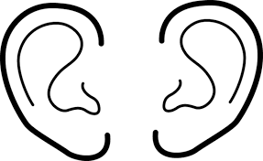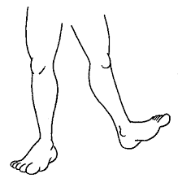

**______________ ______________**

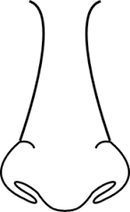

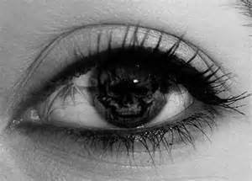

 **__________**

**_______________**

**11.** Match Christian names to their meanings.

Esther saviour

Peter bee

Jesus star

Debora rock

**12.** Write any four animals God created.

i) _________________________ ii) ______________________

iii) ________________________ iv) ______________________

**13.** ______________ leads prayers in the mosque. (Imam, Ali)

**14.** Circle leaders in the church.

bishop, John, pastor, Tom, reverend

**15.** Name any four people who help us at home

i) _________________________ ii) _______________________

iii) _______________________ iv) _______________________

**16.** Name these symbols of Islam

**______________________**

**______________________**

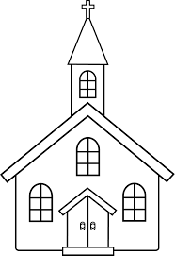**17.** Match correctly.

mosque

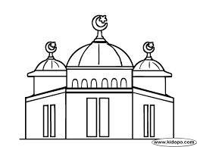

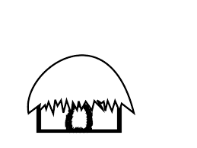 shrine

church

**18.** Name these things used for baptism

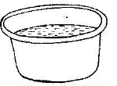

_____________________

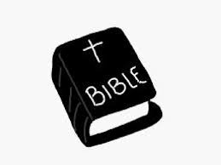

__________________

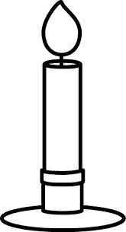

___________________

(Holy Bible, holy water, holy candle)

**19.** Draw these things made by man.

|  |  |  |  |
| --- | --- | --- | --- |
|  |  |  |  |
| car | bag | book | pot |